15TH ANNUAL BERRIEN COUNTY HARVEST FESTIVAL
2025 FOOD VENDOR CHECK IN/SET UP INFORMATION
SATURDAY OCTOBER 18TH, 2025 | 9:00AM - 2:30PM

The Berrien County 2025 Harvest Festival is presented by Nashville Main Street and
Berrien County Chamber of Commerce in Historic Downtown Nashville, Georgia.

- Early bird fee is $75 per space. Must be post marked or in hand by September 1st. Vendor fee becomes $100 per space after September 1st. ALL vendor fees and contracts are due on or before October 3rd. *Please make checks payable to Berrien County Harvest Festival.
- Upon arrival, vendors must check in at the Main Street booth located on the corner of S Davis Street and W Washington Avenue between 6 AM and 7:30 AM to receive space assignments and further instructions. You will be notified by email or phone if we do an early check-in on Friday, October 17th.
- Vendors must be set up and ready to serve promptly by 8:30 AM and will remain open until 2:30 PM in the afternoon. No early breakdowns will be allowed.
- No trailers or trucks will be allowed in the exhibit area after 8:00am. Please allow ample time to arrive and get set up.
- Food vendor spaces are 12’ deep x 14’ wide. Free-standing tents, tables, chairs, displays, merchandise, etc., must fit within your booth space. NOTHING IS TO EXTEND BEYOND YOUR VENDOR SPACE.
- Vendors must have their own tents, tables, chairs, displays, and any other needed items to man their booth. Electricity is very limited and will be first come first serve. If you need to use a generator it must be gas powered and less than 60 db.
- Vendors must specify items to be prepared and sold on the application. Only those items may be prepared. The sponsors reserve the right to limit vendor menus.
- Upon leaving the festival, be sure that you have disposed of any empty boxes, trash, etc., by placing the items in a trash can or beside the trash can by 4 PM.
- No refunds due to rain or inclement weather situation will be issued.
- Alcoholic beverages may not be served or sold.
- Please include a picture of what you will be exhibiting when returning the application. Exhibitors agree to allow the sponsors to use pictures for promotional purposes.
- The committee reserves the right to reject any application.

For questions not covered on this information sheet or other concerns, call Main Street at (229) 686-5527, or the Chamber at (229) 686-5123. If no answer, please leave a message and give us 24 hours to return your call.
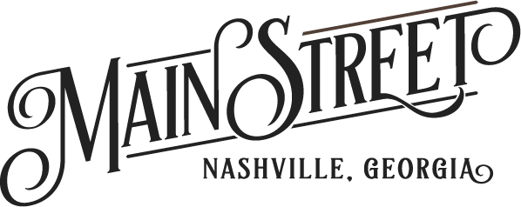
15TH ANNUAL BERRIEN COUNTY HARVEST FESTIVAL
2025 FOOD VENDOR CONTRACT
SATURDAY, OCTOBER 18TH 2025 | 9:00AM - 2:30PM

Fill out this contract and return with your check or money order to Berrien County Chamber of Commerce; Attention: Harvest Festival; P.O. Box 217; Nashville, GA 31639. Make your check or money order out to Berrien County Harvest Festival.

CONTRACT DEADLINE: OCTOBER 3rd, 2025.
Early bird fee is $75 per space. Must be post marked or in hand by September 1st. Vendor fee becomes $100 per space after September 1st. ALL vendor fees and contracts are due on or before October 3rd. Payment is due when the application is returned to reserve your spot.

NAME: LAST__________________________________________ FIRST________________________________________________
NAME AND PHONE NUMBER FOR EMERGENCY CONTACT: ___________________________________________________
RETAIL/BUSINESS NAME: ___________________________________________________________________________________
MAILING ADDRESS: ________________________________________________________________________________________
CITY: ____________________________________________________ STATE: _________ ZIP CODE: ______________________
PHONE: HOME _________________________________________ CELL ______________________________________________
EMAIL ADDRESS: ___________________________________________________________________________________________
MERCHANDISE: (List ALL items to be sold) ____________________________________________________________________ ____________________________________________________________________________________________________________
I AM USING A FREE-STANDING TENT: YES_____ NO_____ HEIGHT OF TENT IN FEET: _______
I AM USING A GENERATOR THAT IS POWERED BY GAS AND IS LESS THAN 60 DB: YES_____ NO_____
Reminder: Free-standing tents, tables, chairs, displays, merchandise, etc., must fit within the space you choose.
NUMBER OF SPACES REQUESTED: ______12’ X 14’ (MAX OF 2) @ $75.00 PER SPACE (EARLY BIRD PRICE) _____________
$100.00 PER SPACE (REGULAR PRICE) _____________

AMOUNT ENCLOSED: ________________

SIGNATURE: ______________________________________________________________ DATE: _________________________

